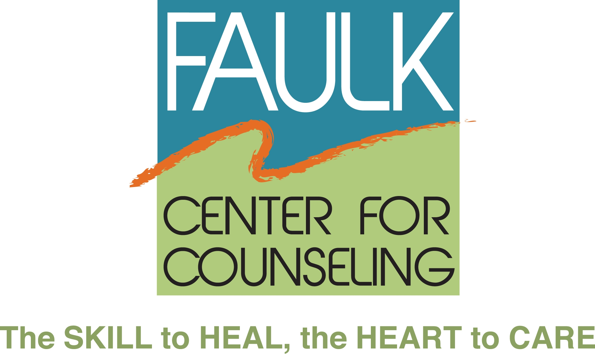

Media Contact:
Cindy Malin
Ambit Advertising and Public Relations DRAFT FOR APPROVAL
(954) 568-2100, ext. 105 February 7, 2013
cindy@ambitmarketing.com

CENTER FOR GROUP COUNSELING ANNOUNCES
NEW NAME AND NEW CEO

Boca Raton, FL – After 40 years, the Center for Group Counseling is changing its name to the Faulk Center for Counseling. The new name, along with a redesigned brand, logo and tagline The SKILL to HEAL, the HEART to CARE reflect the commitment of Dr. Elizabeth H. Faulk who founded the Center in 1973 with the goal of providing free and low-cost emotional support to people of all ages, regardless of their ability to pay.

Over the years, the Center has expanded its programs and services while it continues to assure that people in need have access to quality services. The new name will allow the Center to continue to grow and expand to meet the needs of the community. The values and unsurpassed commitment to the emotional well-being of the South Florida community have not changed.

The Faulk Canter has named Vicki Katz as Chief Executive Officer. Katz brings many years of experience in nonprofit leadership, board development and fund-raising achievements. She will be instrumental in leading the campaign to rebrand the Faulk Center and enhance its presence in the community.

“We welcome Vicki’s experience and leadership to the Faulk Center,” said Kenneth Stevenson, President of the Board of Trustees. “Her enthusiasm and commitment to our goals and values, and her strong belief in the power of philanthropy will expand our ability to make a difference in
people’s lives.”

“The Faulk Center for Counseling has helped thousands of children, adults and families. I look forward to building on the strength of its existing programs and reputation and increasing its visibility in the community and surrounding areas,” commented Katz. “With a mix of grants, annual support and the development of a planned giving program to grow our endowment, we will insure that we are here for another 40 years to support the South Florida community,”

Ms. Katz has held senior-level positions in the nonprofit sector at the Slomin Family Center for Autism and Related Disabilities, The Anti-Defamation League (ADL), Florida Atlantic University (FAU), and Jewish Adoption and Foster Care Options (JAFCO). She holds a Bachelor of Science degree from Nova Southeastern University and is a Certified Fund Raising Executive (CFRE).

About the Faulk Center for Counseling:
The Faulk Center for Counseling, formerly the Center for Group Counseling, has been providing free and low-cost emotional support since 1973. The Faulk Center offers individual and group counseling to people of all ages who might otherwise be unable to afford private mental health services. The Faulk Center provides psychological and mental health counseling to everyone from children to the elderly, including individual, couples and families plus support groups for specific concerns including bereavement, caregivers, divorce and separation, men’s, women’s and senior’s issues. Groups are led by graduate students pursuing doctoral and master’s degrees and are co-led by volunteer group leaders. All volunteers and graduate students are trained and supervised by the Faulk Center for Counseling’s staff of licensed clinical professionals.
For more information, visit www.faulkcenterforcounseling.org or call 561-483-5300.

