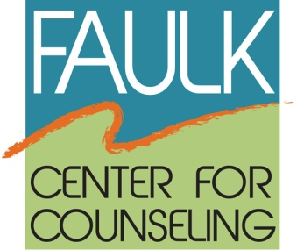

FOR IMMEDIATE RELEASE

Media Contact:
Vicki Katz, Elizabeth H. Faulk Foundation, Inc.
Faulk Center for Counseling
561.583.5300
v.katz@faulkcenterforcounseling.org

FAULK CENTER FOR COUNSELING RECEIVES GRANT FROM CITY OF BOCA RATON

Boca Raton (October 8, 2013) --The Faulk Center for Counseling is pleased to announce that it has been awarded a $10,000 grant from the City of Boca Raton to provide mental health services. The Faulk Center for Counseling offers free or low-cost counseling and emotional support to adults, children, seniors, families and couples at our location in Boca Raton and at outreach locations in Palm Beach County. Funds will be utilized for clinical staffing of the Individual, Family and Group Counseling Programs for children, teens, adults and seniors, who come from low income families. The Faulk Center for Counseling is committed to making services available across our community, regardless of ability to pay.

“This grant reflects the commitment of our city officials to the importance of mental health in our community, and of the need to provide access to those who might otherwise be unable to afford treatment”, states Vicki Katz, Chief Executive Officer at the Faulk Center. “We are most appreciative of this funding and look forward to a continuing partnership with the City of Boca Raton”.

About the Faulk Center for Counseling
The Faulk Center for Counseling, formerly the Center for Group Counseling, has been providing free and low-cost mental health services since 1973 to people of all ages. The Faulk Center provides psychological and mental health counseling to everyone from children to the elderly, including individual, couples and families plus support groups for specific concerns including caregivers, divorce and separation, men’s, women’s and senior’s issues. Groups are led by graduate students pursuing doctoral and master’s degrees and are co-led by volunteer group leaders. All volunteers and graduate students are trained and supervised by the Faulk Center for Counseling’s staff of licensed clinical professionals.
For more information, visit www.faulkcenterforcounseling.org or call 561-483-5300.
###
Faulk Center for Counseling - 22455 Boca Rio Road - Boca Raton, Florida 33433 - 561.583.5300

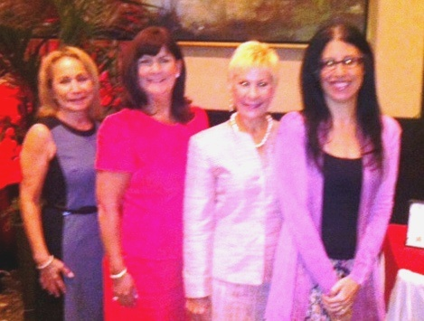

PHOTO CAPTION: From the Left,
Vicki Katz (CEO, Faulk Center for Counseling), Deputy Mayor Susan Haynie (City of Boca Raton), Council Member Constance Scott (City of Boca Raton) and Dr. Holly Katz (Clinical and Training Director, Faulk Center for Counseling)

