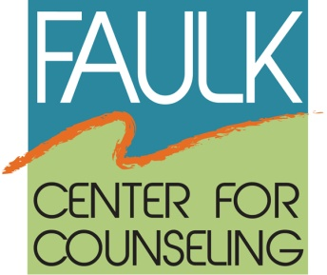

FOR IMMEDIATE RELEASE

Media Contact:
Vicki Katz, Elizabeth H. Faulk Foundation, Inc.
Faulk Center for Counseling
561.583.5300
v.katz@faulkcenterforcounseling.org

FAULK CENTER FOR COUNSELING RECEIVES GRANT FROM THE JIM MORAN FOUNDATION
FOR SCHOOLS PREVENTIVE COUNSELING PROGRAM

Boca Raton (September 23, 2013) --The Faulk Center for Counseling is pleased to announce that it has been awarded a $57,000 grant from The Jim Moran Foundation for the Schools Preventive Counseling Program for the 2013-2014 academic year.

Since 2004, The Foundation has provided more than $225,000 for this collaborative effort among parents, caregivers, teachers, school guidance counselors and the Faulk Center to address the mental health needs of at-risk elementary and middle school children.

In a safe, supportive setting, through both structured and unstructured activities, children in the program learn and repeatedly practice problem solving, decision making, interpersonal skills, and emotional self-control. This increases their sense of self and encourages them to separate from peers who make risky, problematic choices such as self-injurious behavior or joining a gang. Ultimately these factors help divert children from a trajectory of increasing violence and are also considered the best predictors of a child’s ability to continue in school and prepare for a meaningful, productive future.

During the last school year, the Faulk Center provided group counseling services to 185 children in nine Palm Beach County Title 1 schools.

“We are truly grateful for the partnership and support of The Jim Moran Foundation,” states Dr. Holly Katz, Clinical Director at the Faulk Center. “The impact of this program has been impressive and demonstrates that our counseling and behavioral techniques are effective in enhancing children’s emotional and social functioning.”

About the Faulk Center for Counseling
The Faulk Center for Counseling, formerly the Center for Group Counseling, has been providing free and low-cost mental health services since 1973 to people of all ages. The Faulk Center provides psychological and mental health counseling to everyone from children to the elderly, including individual, couples and families plus support groups for specific concerns including caregivers, divorce and separation, men’s, women’s and senior’s issues. Groups are led by graduate students pursuing doctoral and master’s degrees and are co-led by volunteer group leaders. All volunteers and graduate students are trained and supervised by the Faulk Center for Counseling’s staff of licensed clinical professionals.
For more information, visit www.faulkcenterforcounseling.org or call 561-483-5300.
About The Jim Moran Foundation

Founded by automotive pioneer Jim Moran, the mission of The Jim Moran Foundation is to improve the quality of life for the youth and families of Florida through the support of innovative programs and opportunities that meet the ever-changing needs of the community. The Foundation has invested more than $40 million in education, elder care, family strengthening, after school and youth transitional living initiatives since its inception in 2000 with efforts currently focused in Broward, Palm Beach and Duval counties. Through a long-term Grant Agreement, The Foundation's significant funders are JM Family Enterprises, Inc., and its subsidiaries, including Southeast Toyota Distributors, LLC. It is located at 100 Jim Moran Blvd., Deerfield Beach, Fla. 33442. To learn more, visit www.jimmoranfoundation.org or call (954) 429-2122.
###

Faulk Center for Counseling - 22455 Boca Rio Road - Boca Raton, Florida 33433 - 561.583.5300

