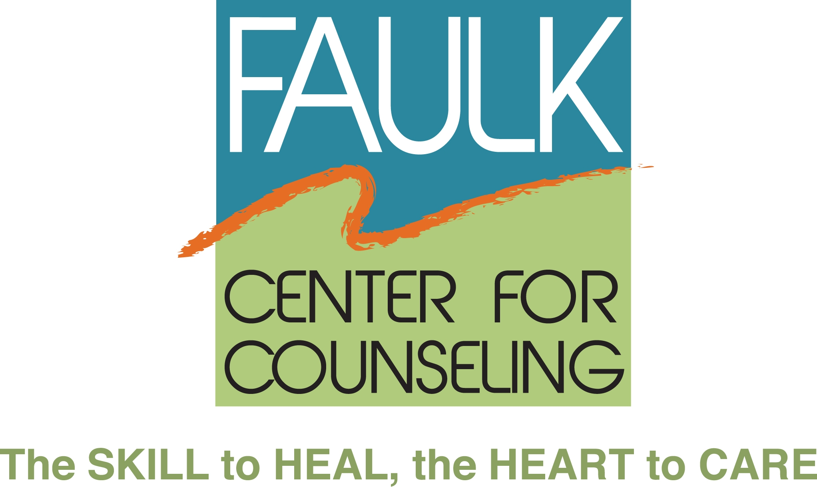

Media Contact:
Cindy Malin
Ambit Advertising and Public Relations DRAFT FOR APPROVAL
(954) 568-2100, ext. 105 March 12, 2013
cindy@ambitmarketing.com

FAULK CENTER FOR COUNSELING ANNOUNCES
NEW BOARD OF TRUSTEES

Boca Raton, FL – The Faulk Center for Counseling announces their 2013 Board of Trustees. Dr. Kenneth Stevenson has been appointed as President and Mara Bernstein, Esq. has been appointed as a new member. The Faulk Center for Counseling was formerly known as the Center for Group Counseling.

Dr. Kenneth Stevenson is Associate Vice President, Development for the Broward College Foundation and has been a Board of Trustee member since 2010. He was in private practice for several years and his professional background has centered on colleges, universities and not-for-profit organizations having been a VP, CEO and Dean. “We are committed to honoring Dr. Elizabeth Faulk’s vision to provide free and low-cost emotional support to the South Florida community,” stated Dr. Stevenson. “The Faulk Center for Counseling has provided services to thousands of people and it is important to continue to get the word out that these quality services are available.” Dr. Stevenson has his PhD in clinical psychology.

Mara Bernstein, Esq. is an Associate at the Law Offices of Barry I. Finkel P.A. in Fort Lauderdale.

- more -

FAULK CENTER FOR COUNSELING NEW BOARD OF TRUSTEES
PAGE 2

Eight additional members continue to serve on the Faulk Center for Counseling Board of Trustees:

Lois A. Weisman, First Vice President
Clement C. Winke, Jr., Treasurer
Peter Weintraub, Esq., Secretary
Robert Drimmer, M.D.
Ronald A. Mercer, Ph.D.
Edith Pearson
Emily Rosen, M.A.
Teresa B. Sjogren, Esq.

About the Faulk Center for Counseling:
The Faulk Center for Counseling, formerly the Center for Group Counseling, has been providing free and low-cost emotional support since 1973. The Faulk Center offers individual and group counseling to people of all ages who might otherwise be unable to afford private mental health services. The Faulk Center provides psychological and mental health counseling to everyone from children to the elderly, including individual, couples and families plus support groups for specific concerns including bereavement, caregivers, divorce and separation, men’s, women’s and senior’s issues. Groups are led by graduate students pursuing doctoral and master’s degrees and are co-led by volunteer group leaders. All volunteers and graduate students are trained and supervised by the Faulk Center for Counseling’s staff of licensed clinical professionals.
For more information, visit www.faulkcenterforcounseling.org or call 561-483-5300.

###

